**Step 4: Booth Multiplier Implementation**

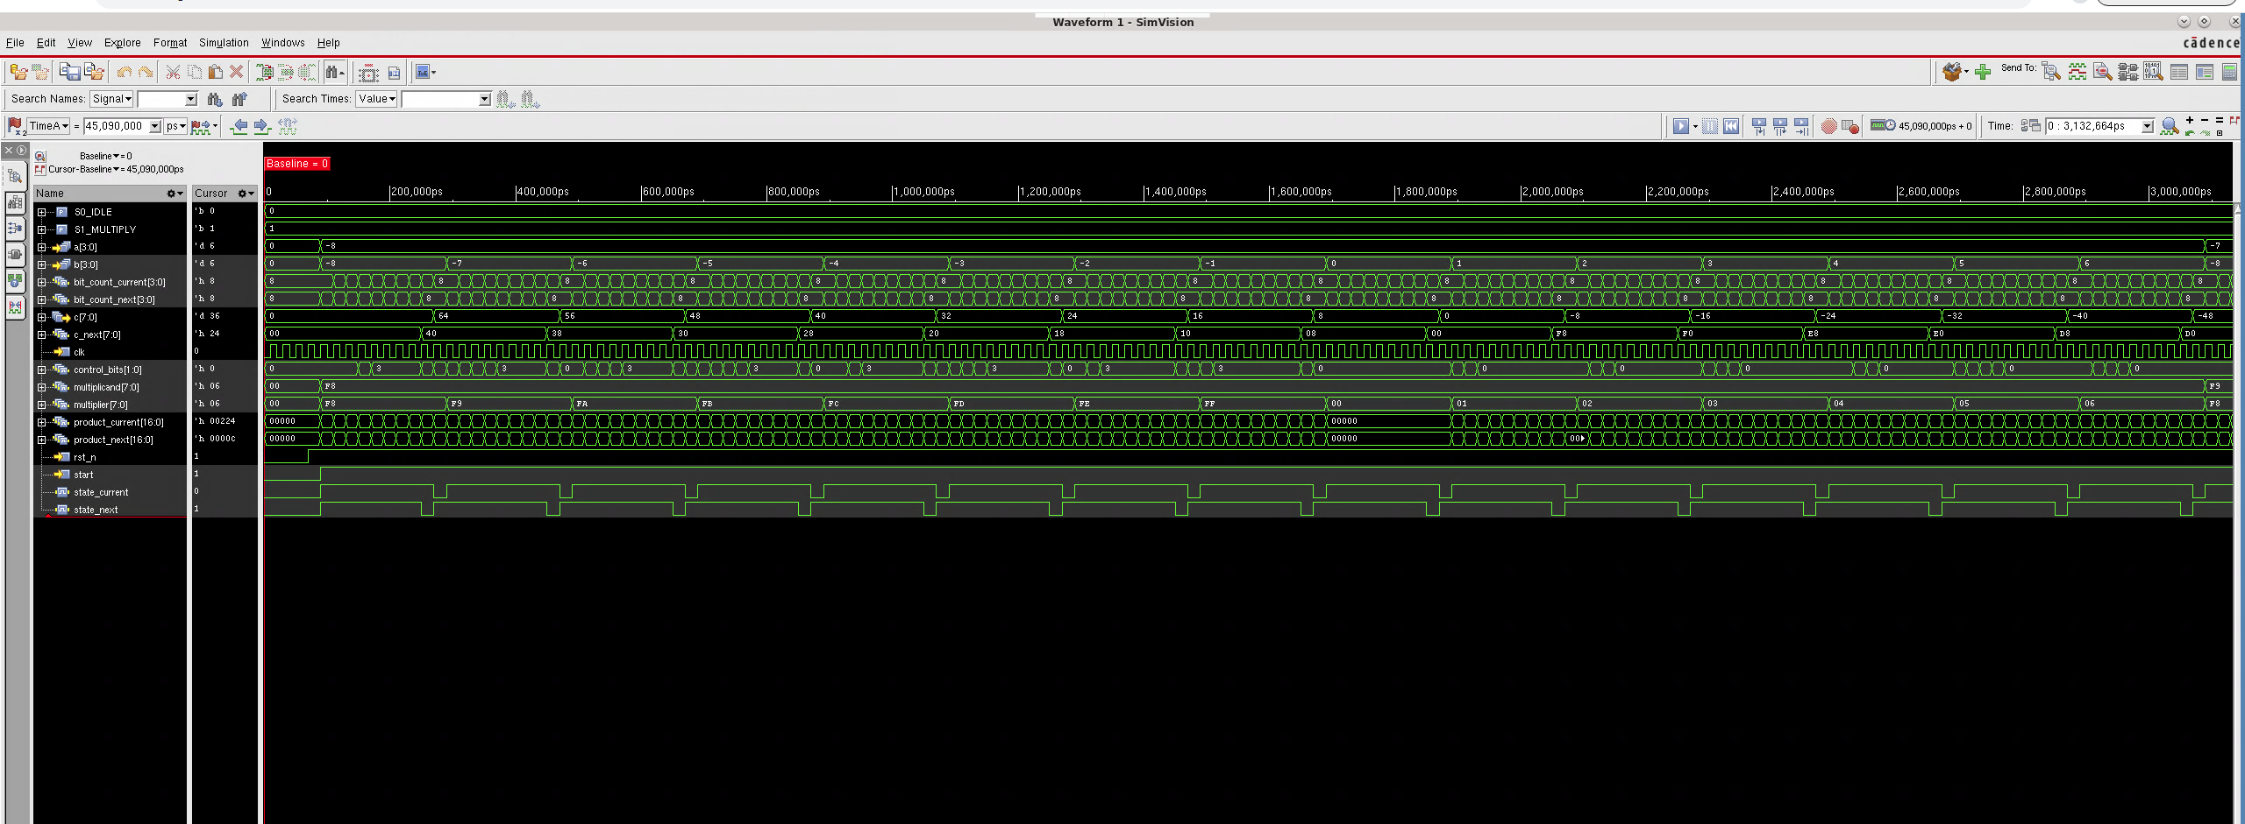

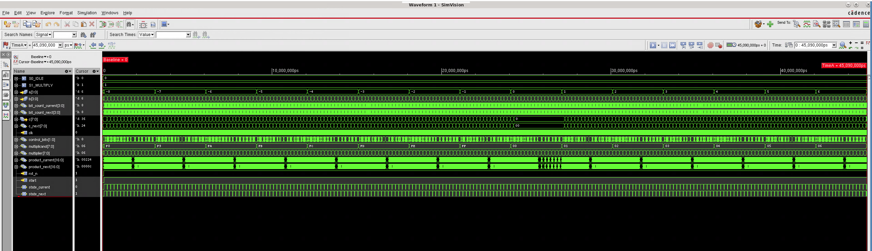

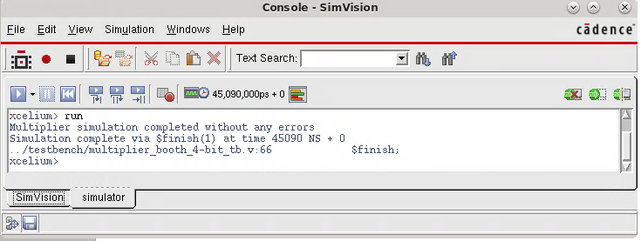

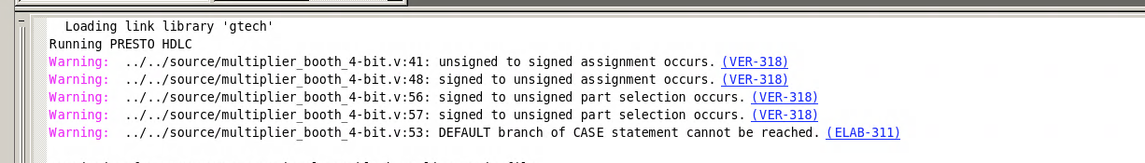

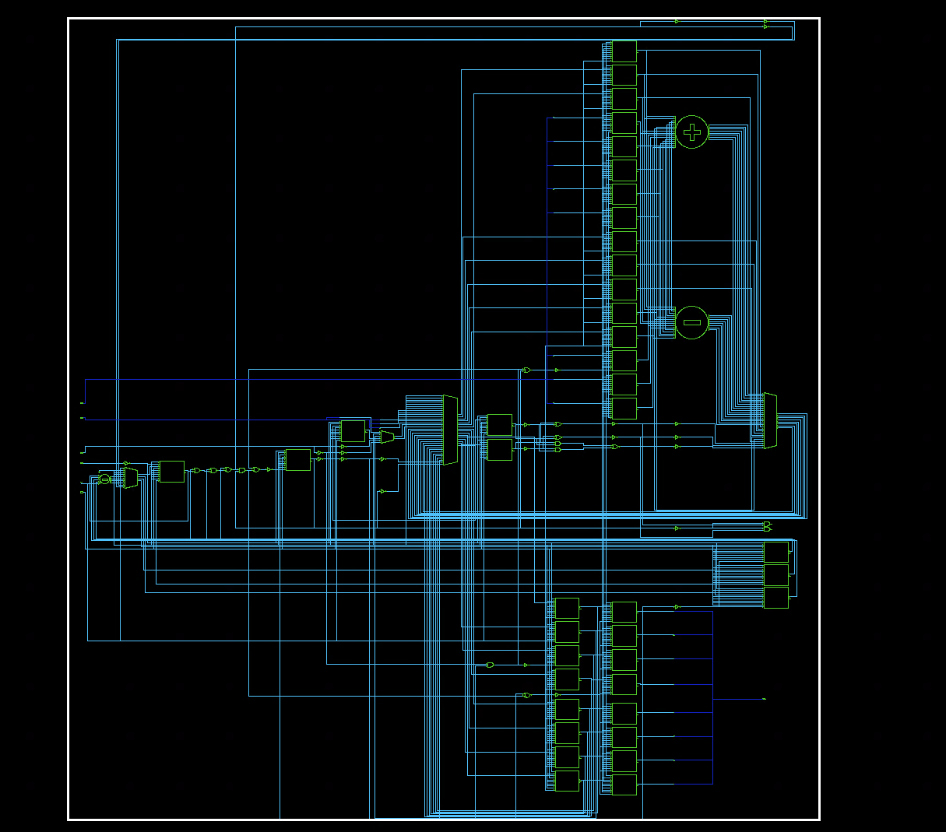

The hardware implementation matches expectations because the booth multiplier implements addition, subtraction, and a shift register. All of which were observed in the circuit that the synthesis tool produced.